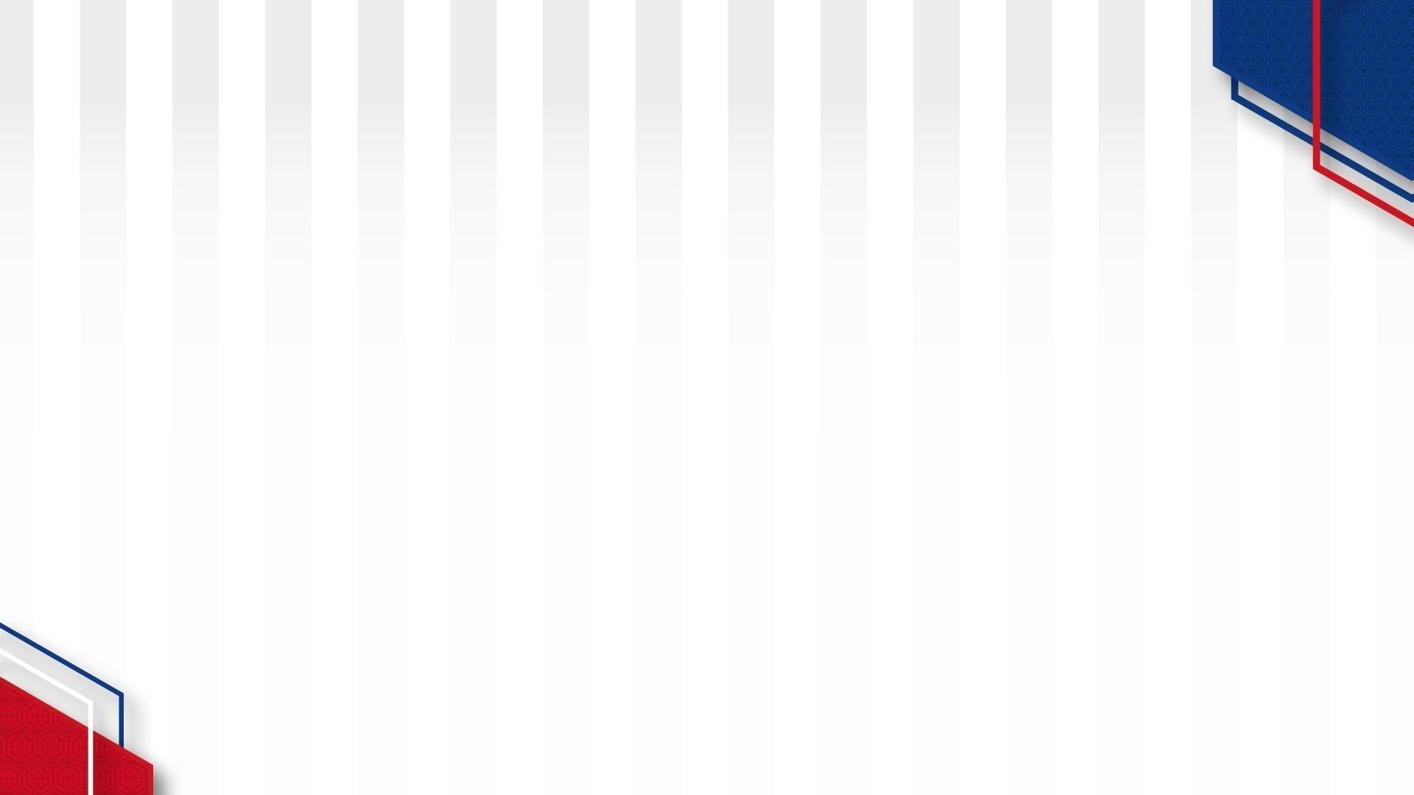



**Jr. NBA League Sul**

**Regular Season **

Quadro Competitivo | Division PACIFIC

|  |  |  |  |  |  |
| --- | --- | --- | --- | --- | --- |
| **Data** | **Local** | Pavilhão – | | | |
| Hora | Jogo | | | |
| 09h00 | A x B | GOLDEN STATE WARRIORS |  | LOS ANGELS CLIPPERS |
| 09h00 | C x D | LOS ANGELS LAKERS |  | PHOENIX SUNS |
| 09h45 | D x A | PHOENIX SUNS |  | GOLDEN STATE WARRIORS |
| 09h45 | B x E | LOS ANGELS CLIPPERS |  | SACRAMENTO KINGS |
| 10h30 | E x C | SACRAMENTO KINGS |  | LOS ANGELS LAKERS |
| 10h30 | D x B | PHOENIX SUNS |  | LOS ANGELS CLIPPERS |
| 11h15 | A x C | GOLDEN STATE WARRIORS |  | LOS ANGELS LAKERS |
| 11h15 | D x E | PHOENIX SUNS |  | SACRAMENTO KINGS |
| 12h00 | A x E | GOLDEN STATE WARRIORS |  | SACRAMENTO KINGS |
| 12h00 | B x C | LOS ANGELS CLIPPERS |  | LOS ANGELS LAKERS |

|  |  |  |  |  |  |  |  |  |
| --- | --- | --- | --- | --- | --- | --- | --- | --- |
| Classificação 1ªJornada | | | | | | | | |
| Equipa | PM | PS | PM-PS | V | D | Jogos | Pontos | Classificação |
| GOLDEN STATE WARRIORS |  |  |  |  |  |  |  |  |
| PHOENIX  SUNS |  |  |  |  |  |  |  |  |
| LOS ANGELS  CLIPPERS |  |  |  |  |  |  |  |  |
| SACRAMENTO  KINGS |  |  |  |  |  |  |  |  |
| LOS ANGELS  LAKERS |  |  |  |  |  |  |  |  |





**Jr. NBA League Sul**

**Regular Season **

Quadro Competitivo | Division PACIFIC

|  |  |  |  |  |  |  |  |  |
| --- | --- | --- | --- | --- | --- | --- | --- | --- |
| Classificação FINAL | | | | | | | | |
| Equipa | PM | PS | PM-PS | V | D | Jogos | Pontos | Classificação |
| GOLDEN STATE  WARRIORS |  |  |  |  |  |  |  |  |
| PHOENIX  SUNS |  |  |  |  |  |  |  |  |
| LOS ANGELS  CLIPPERS |  |  |  |  |  |  |  |  |
| SACRAMENTO  KINGS |  |  |  |  |  |  |  |  |
| LOS ANGELS  LAKERS |  |  |  |  |  |  |  |  |

|  |  |  |  |  |  |
| --- | --- | --- | --- | --- | --- |
| **Data** | **Local** | Pavilhão – | | | |
| Hora | Jogo | | | |
| 09h00 | A x B | GOLDEN STATE WARRIORS |  | LOS ANGELS CLIPPERS |
| 09h00 | C x D | LOS ANGELS LAKERS |  | PHOENIX SUNS |
| 09h45 | D x A | PHOENIX SUNS |  | GOLDEN STATE WARRIORS |
| 09h45 | B x E | LOS ANGELS CLIPPERS |  | SACRAMENTO KINGS |
| 10h30 | E x C | SACRAMENTO KINGS |  | LOS ANGELS LAKERS |
| 10h30 | D x B | PHOENIX SUNS |  | LOS ANGELS CLIPPERS |
| 11h15 | A x C | GOLDEN STATE WARRIORS |  | LOS ANGELS LAKERS |
| 11h15 | D x E | PHOENIX SUNS |  | SACRAMENTO KINGS |
| 12h00 | A x E | GOLDEN STATE WARRIORS |  | SACRAMENTO KINGS |
| 12h00 | B x C | LOS ANGELS CLIPPERS |  | LOS ANGELS LAKERS |